Exposed Reaction Worksheet
Introduction: In the presence of water, citric acid [C₆H₈O₇] and sodium bicarbonate [NaHCO₃] (also known as baking soda) react to form trisodium citrate [Na₃C₆H₅O₇], water [H₂O] and carbon dioxide [CO₂].
To keep workers safe, chemical engineers must control the temperature and pressure of the reaction so no explosions occur, and to make a profit, they must produce the most carbon dioxide [CO₂] using the least citric acid [C₆H₈O₇].
In groups of two, your engineering task is to test the reaction in the lab before a large scale operation plant is turned on. To keep the plant workers safe and earn profit, you must determine:
- The temperature change that occurs during the reaction. Day 1 and Day 2
- The amount of CO₂ produced. Day 2
- The optimum quantity of reactants to maximize the company's profit. Day 3
Day 1 Procedures
- Collect the following materials (measure as necessary):
- 2 g citric acid (CA)
- 2.6 g sodium bicarbonate (SB)
- 20 ml water
- ziplock bag
- thermometer
Conduct the remaining steps as a group.
- Pour the two powders into one corner of the plastic bag.
- Use both hands to pinch off the powder mixture from the rest of the bag.
- IMPORTANT to keep the water and powder separate. Have your partner carefully pour the water into the opposite corner of the bag. Have your partner seal the plastic bag, and squeeze as much air out (to make the bag flat).
- Set the bottom of the bag on the thermometer bulb and record the temperature.
- When directed, gently release your hand from around the powder and tilt the bag to permit the water and powder to mix.
- Do NOT shake the bag.
- In Table 1, record the temperature in 60-second intervals.

- Complete the table.
Table 1: Record Temperature Measurements from Day 1 Experiment
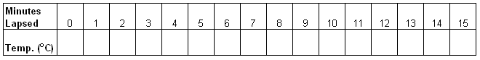

- Plot the data from Table 1.
Chart 1: Plot the data collected in Table 1
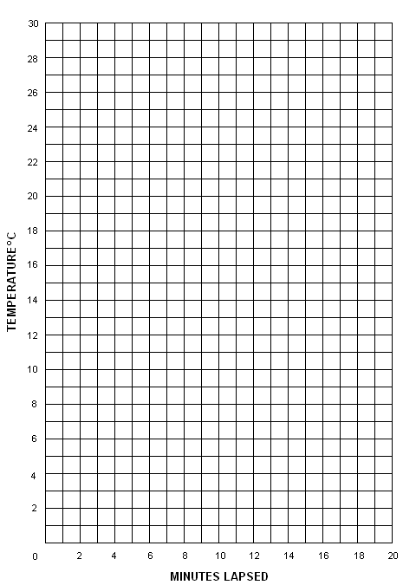

3. Did the last temperature return to the first temperature?
Day 2: Return to your groups of two from yesterday. You will test the same reaction as yesterday but use different amounts of citric acid and sodium bicarbonate. By collecting data using different amounts of citric acid, we will be able to “optimize” the reaction, or design the reaction to create the most profit.
Depending on your assigned group, you will test using the following quantities of reactants with 20 ml of water.
Group A: 1 g CA + 2.6 g SB Group C: 2 g CA + 5.2 g SB
Group B: 4 g CA + 5.2 g SB Group D: 6 g CA + 7.8 g SB
1. What will happen to the temperature during the reaction?
Hypothesis: ___________________________________________________________________
__________________________________________________________________________________________________________________________________________________________________________________________________________________________________________
2. What will happen to the quantity of carbon dioxide produced from the reaction?
Hypothesis: ___________________________________________________________________
__________________________________________________________________________________________________________________________________________________________________________________________________________________________________________
Procedures
- Collect the following materials (measure as necessary):
- citric acid (CA)
- sodium bicarbonate (SB)
- 20 ml water
- ziplock bag
- thermometer
- syringe
- piece of BLUE tape
- Pour the two powders into one corner of the plastic bag.
- Use both hands to pinch off the powder mixture from the rest of the bag.
- IMPORTANT to keep the water and powder separate. Carefully have your partner pour the water into the opposite corner of the bag. Have your partner seal the plastic bag, and squeeze as much air out (to make the bag flat).
- Set the bottom of the bag on the thermometer bulb and record the temperature.
- When directed, gently release your hand from around the powder and tilt the bag to permit the water and powder to mix.
- Do NOT shake the bag.
- In Table 2, record the temperature in 60-seconds intervals.
- Wait until the reaction is complete and the temperature has returned to the original temperature.
- IMPORTANT, this step must be done very quickly to prevent loss of carbon dioxide from the bag.
- Open a small part of the bag, place the syringe tip into the bag, and pull plunger until the all of the carbon dioxide is removed from the bag.
- Quickly seal the tip of the plunger with tape.
- Complete the table.
Table 2: Record Temperature Measurements from Day 2 Experiment

- Plot the data from table 2.
Chart 2: Plot the data collected in Table 2

3. What was the observed difference between the Day 1 results and the Day 2 results? (For example, more or less bubbling, lower or higher temperatures?)

Day 3: We ran a series of experiments using citric acid (CA) and sodium bicarbonate (SB). The reaction resulted in two observations: temperature drop and gas production. The gas produced was carbon dioxide (CO₂). The goal of this experiment was to know how to choose the best reaction to make the largest profit (the most money). Below is a summary of the amount of chemicals used by each group.
Group A used: 1 g CA + 2.6 g SB Group C used: 2 g CA + 5.2 g SB
Group B used: 4 g CA + 5.2 g SB Group D used: 6 g CA + 7.8 g SB
Questions
- For Group A the average CO₂ production was ____________ gram/bag.
For Group B the average CO₂ production was ____________ gram/bag.
For Group C the average CO₂ production was ____________ gram/bag.
For Group D the average CO₂ production was ____________ gram/bag.
- Complete Table 3 below, using the average CO₂ production given above.
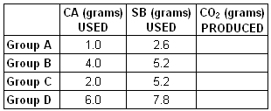
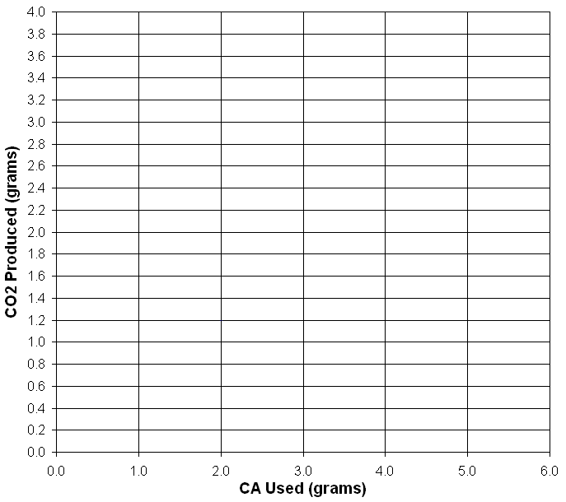

- Complete Table 4 below. The cost for Group A has already been done for you.
CA costs = $0.07/gram
SB costs = $0.35/gram
water + bag costs = $0.10
CO₂ can be sold for = $0.25/gram
- Which reaction should be used so that your company will make the most profit?
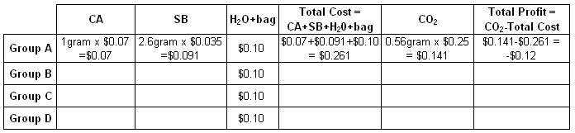
Scale-Up: Instead of running the reaction in a bag, we want to run it in a tank the size of the classroom. Each table: use a measuring tape and work as a team to determine the room size.
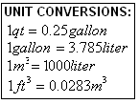
- Length (front of room to back of room): L= _________________ feet
Width (side to side): W=_________________ feet
Height (floor to ceiling): H=_________________ feet

- What is the volume of the room in ft³ (V=L x W x H)? V=_________________ ft³
- If the volume of the bag was 1 quart, how many bags would be needed to equal the volume of the room? Show your work and write your answer in the box below.

Volume of the classroom = Volume of ______ bags

- Using the reaction you picked from question 4, determine the profit of running the experiment in a tank the size of the classroom. (Hint: use your answer from question 7.)

