Ohms Law Worksheet Basic Circuits Name: _________________

Teacher: __________________Period:_____________________ Date:___________________

Circuit Symbol Key: |  |  |  |  |  |  |  |  |  |  | Multimeter
 |  |  |  |  |  | Light bulb |  |  |  |  | Multimeter
 |  |  |  |  |  |  |  |  |  |  | A multimeter can
 |  |  |  |  |  |  |  |  |  | Measure | A multimeter can
 |  |  |  |  |  |  |  |  |  | Measure | measure the
 |  |  |  |  |  |  |  |  |  | Voltage | measure the
 |  |  |  |  |  |  |  |  |  | Voltage | voltage or the
 |  |  |  |  |  |  |  |  |  | Voltage | current. Examples
 |  |  |  |  |  |  |  |  |  |  | below show how to
 |  |  |  |  |  |  |  |  |  |  | measure current or
 |  |  |  |  |  |  |  |  |  | Measure | voltage and the
 |  |  |  |  |  |  |  |  |  | Measure | circuits that are
Light bulbs we are using in this lesson do not |  |  |  |  |  |  |  |  |  | Current | circuits that are
 |  |  |  |  |  |  |  |  |  | Current | consistent with the
have a polarity, there is not + or - . |  |  |  |  |  |  |  |  |  |  | consistent with the
 |  |  |  |  |  |  |  |  |  |  | pictures
 |  |  |  |  |  |  |  | Battery |  |  | Switch
- |  |  |  |  |  |  |  |  |  | The knife switch is a simple shorting mechanism
In this lesson we will be using D batteries. Note that in
 |  |  |  |  |  |  |  |  |  | providing a conductive connection when the lever is
the battery pictured above the right side is positive and
 |  |  |  |  |  |  |  |  |  | lowered.
the left is negative. |  |  |  |  |  |  |  |  |  | lowered.
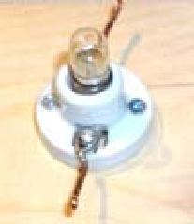


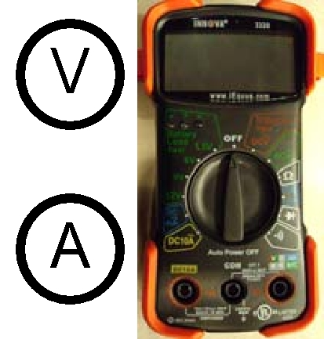
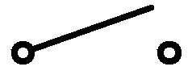


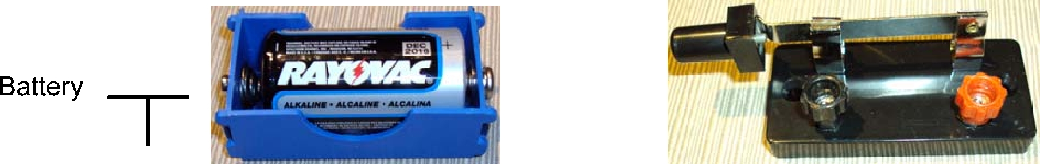

How to measure voltage: How to measure current:
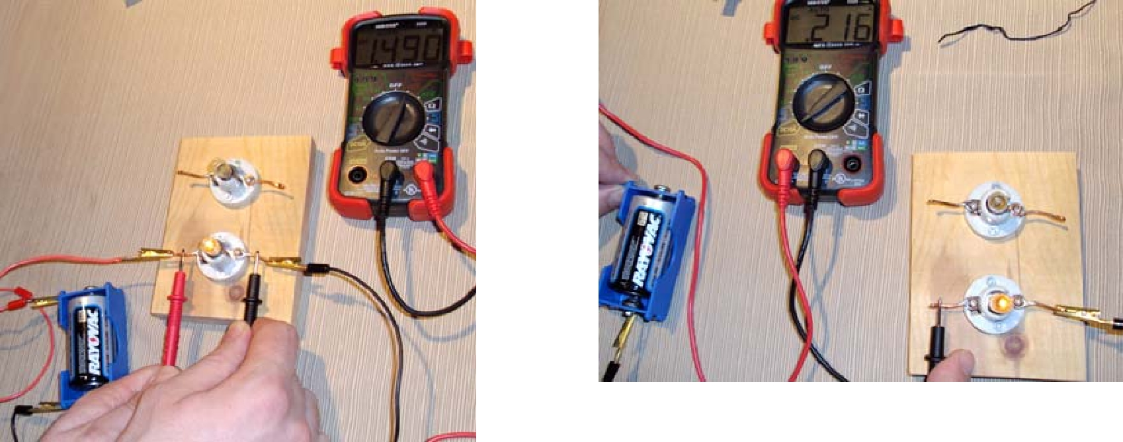

Measure the voltage across a circuit element.
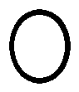
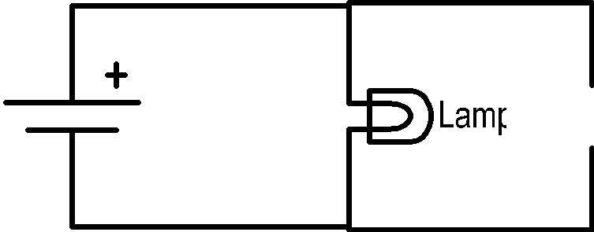

Measure current by making the multimeter part of the circuit.
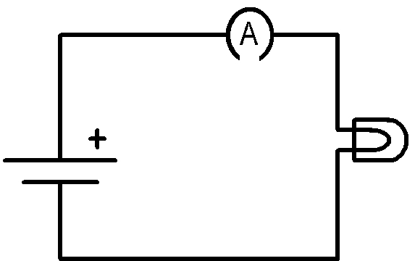

- -
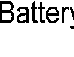




Circuit Reference - Resistors in Series and Parallel

Ohm’s Law |  |  |  |  | I
• Ohm’s Law relates the voltage across a component and the current
through a component given a resistance R.
V | = | IR
 |  |  |  | -
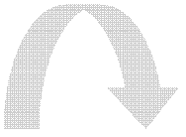

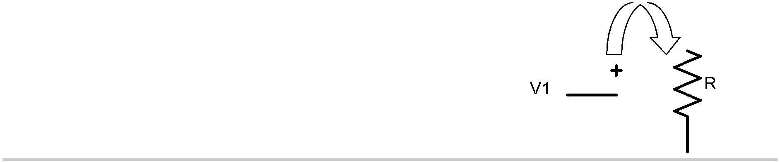
Kirchhoff’s Voltage Law (KVL)

- Kirchhoff’s voltage law states that the sum of the voltage in a closed loop must add to zero.
- Using KVL we can show how resistors should add together when in series.
- Starting at the dot and moving clockwise we can add up the voltage or voltage drop across each component. By convention if a component does note have a stated polarity it will be assumed to be positive.

 |  |  |  |  | Starting at the dot move clockwise
 |  |  |  |  | -V1+V_{R1}+V_{R2}=0 →
 |  |  |  |  | V1 | = V_{R1}+V_{R2} →
 | - |  |  |  | V1 | = I_{R1}R1+I_{R2} R2 → |  | -
 | - |  |  |  | I_{R1}=I _{R2} because current is constant |  |  | -
 | - |  |  |  | V1 | = I(R1+R2) →
 |  |  |  |  | So R_{equiv} = R1+R2
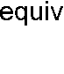
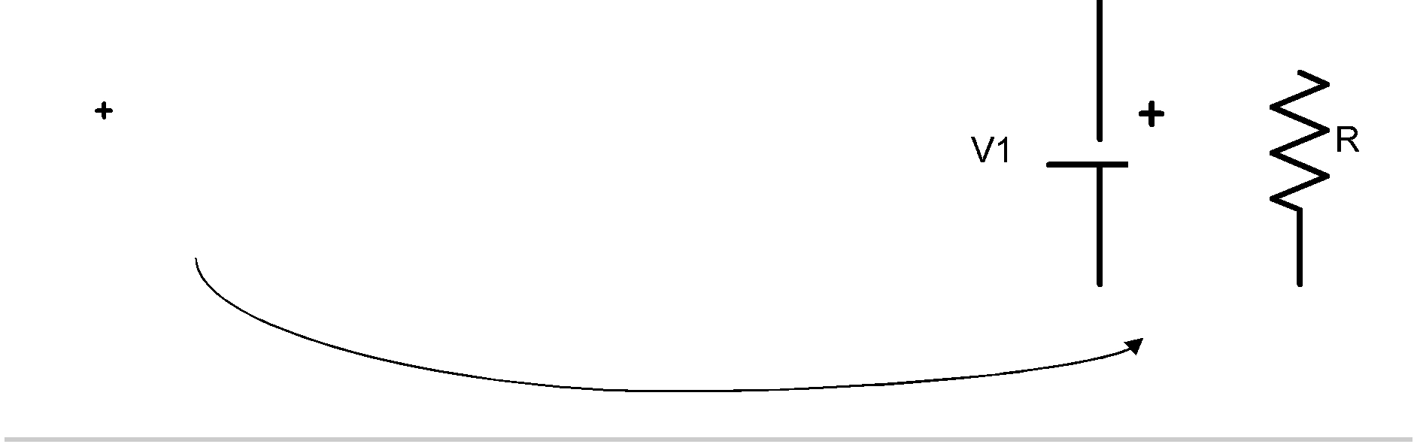
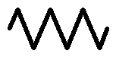



Kirchhoff’s Current Law (KCL)

- Kirchhoff’s current law states that the current into a node must be equal to the current exiting a node.
- KCL can be used to show how resistors add in parallel.
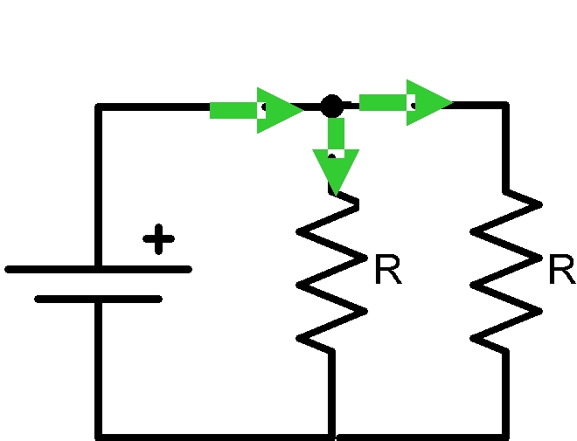

iin iR2

iR1


-

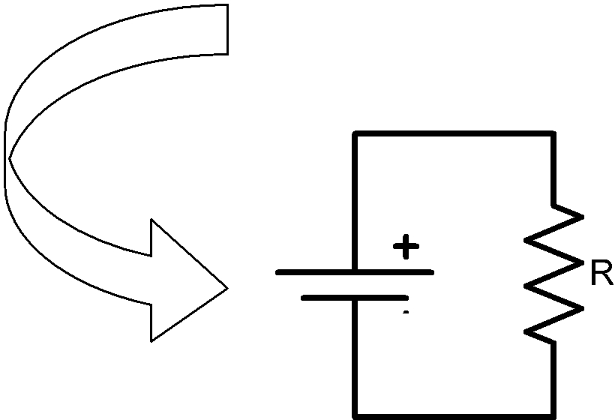

-
At the node the current from the battery comes in and gets split between R1 and R2.
I_{in}-I_{R1}-I_{R2}=0 →
Iin=IR1+IR2 →

I_{in} = (V_{R1}/R1)+(V_{R2} /R2) →
V_{R1}=V _{R2} =V1, because the voltage across both resistors is the same and equal to V1
I_{in} = V1(1/R1+1/R2) →

I_{in} = V1((R1+R2)/R1*R2) →
Rearrange to look like Ohm’s Law

V1 = I(R1*R2/(R1+R2)) →

So | ^{R}equiv ⁼ | R1* R2
So | ^{R}equiv ⁼ | R1+R2
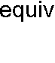

Diagram a Circuit


Using the items listed below determine the circuit that makes the two light the brightest

- 2 lamps
- 2 batteries

- Jumper wires

- 1 Switch (optional)

In the space below draw the circuit diagram of the circuit which made

the light bulbs the brightest

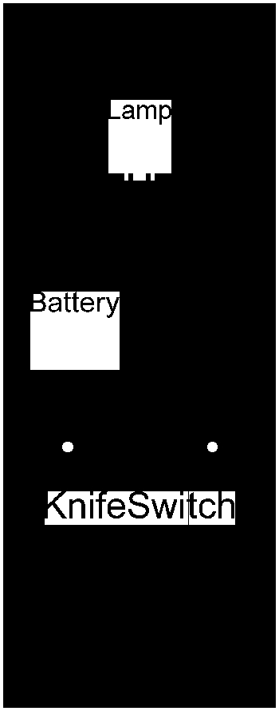

Brightest Lamp Circuit Diagram | Symbol

Wire

- In the circuit diagram above label each component in the diagram include expected voltage of each battery.

- Use the multimeter to measure the voltage of the battery/batteries
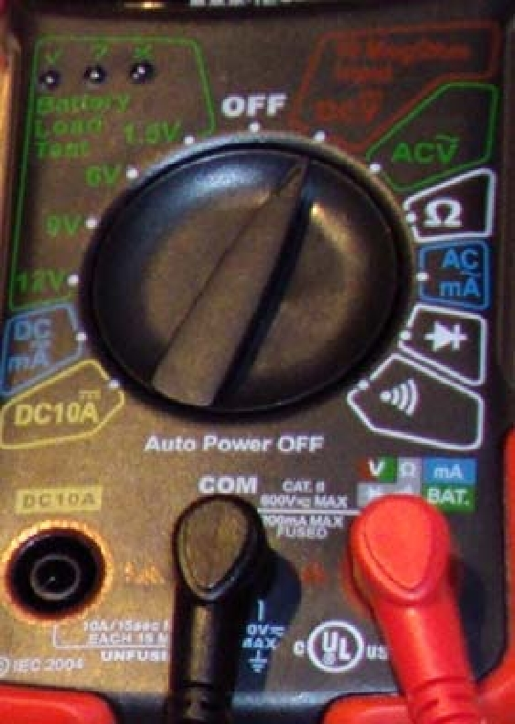
using the settings to the right:

(Place probes on either side of the battery determine the +/ - sides draw a picture of battery and equivalent circuit component with polarity)

Battery 1 ______________ (V)
Battery 2 ______________ (V)
Only if both batteries are used
• Using the values of the batteries from the circuit diagram what is the
total voltage provided to the circuit.
Total Expected Voltage Supplied to Circuit V_{T}= _______________(V) | ⎛ | V_{T} −V_{M} | ⎞
 | % Diff ⎜ | V_{T} −V_{M} | ⎟ | ⋅100[%]
 | ⎜ | V_{T} | ⎟ | ⋅100[%]
• Measure the total voltage supplied to circuit | ⎝ | V_{T} | ⎠



Total Measured Voltage Supplied to Circuit V_{M} = ______________(V)

Lamps in Series - Measure the Voltage

side of the

- Using both lamps build the circuit shown to the right.

- Measure the positive voltage across lamp 1

Lamp 1 Voltage |V_{L1}| = __________(V)

(Measuring the voltage across the lamp is the same as measuring the battery, use the same set
tings, place the probes on either

lamp. )

• Measure the positive voltage across lamp 2 Lamp 2 Voltage |V_{L2}| = __________(V)

-
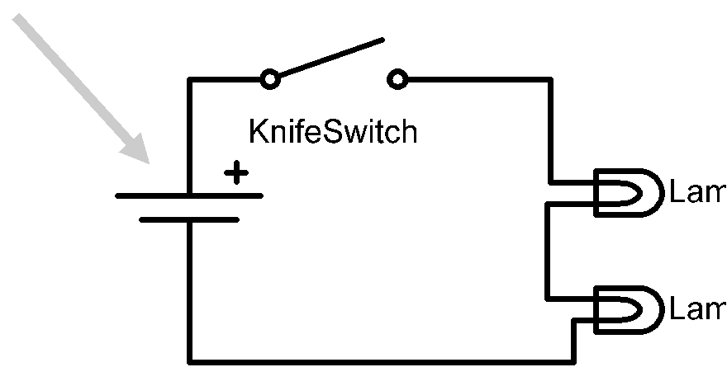

Circuit with 2 lamps in series

Determine the polarity

Kirchhoff’s voltage law (KVL)

- Kirchhoff’s voltage law states that the sum of the voltages in a closed loop must add to zero.
- Take the circuit to the right, if you start at the dot and go clock wise you can write down the following equation.

-V₁ +/- V_{R1} +/-V_{R2} = 0

We know the polarity or sign of the battery and if you think about walking around the circuit like you where walking on a path you would first see the negative side of the battery so you put a - in front of V₁. By convention we apply a positive sign to circuit components when we do not know the polarity. So the equation above would be: -V₁ + V_{R1} +V_{R2} = 0 or V₁=V_{R1} +V_{R2}

So we can label the polarity of each component as

Check: | + |  | =
VR1 |  | VR2 | Is this close to
VR1 |  | VR2 | V1?

-
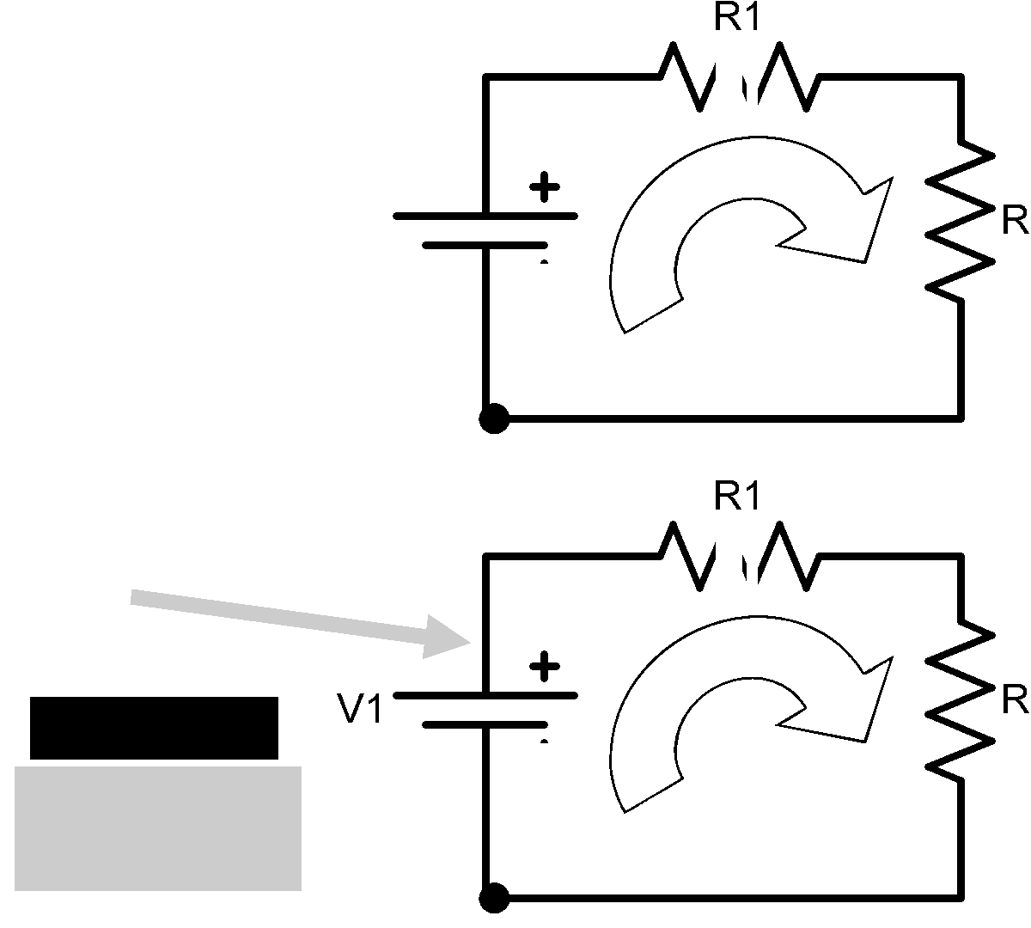

+ -

+

- | -

• Using the convention above label the circuit to the right and measure the voltage across lamp 1

Lamp 1 Voltage V_{L1} = __________(V)

(Place the red probe on the plus side and the black on the negative side )

• Measure the voltage across lamp 2

Lamp 2 Voltage V_{L2} = __________(V)

-
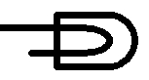

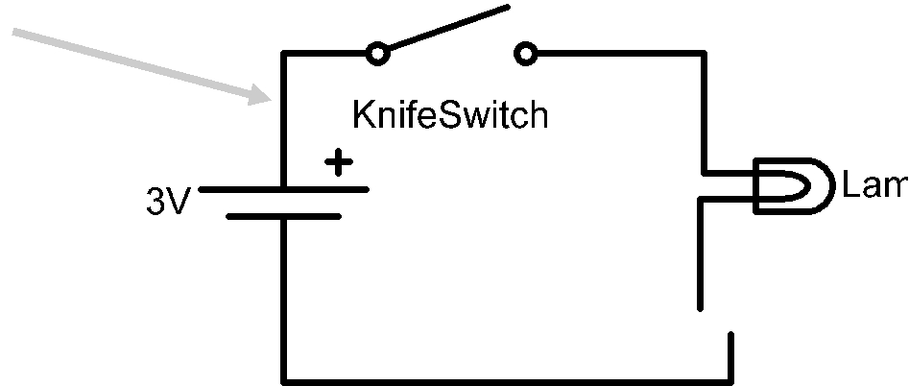

Circuit with 2 lamps in series

Lamps in Series -

Measure the Current
-
Circuit with 2 lamps in series
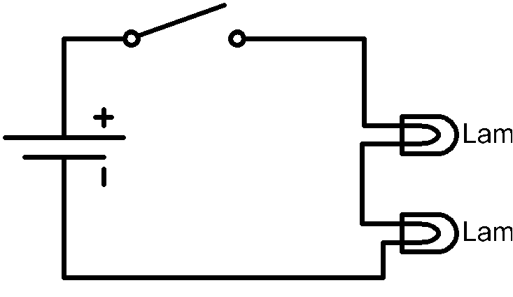


• Now that we know the voltage across each lamp lets measure the current through each lamp.

• Voltage can be thought of as the potential of getting something done. You can also think of voltage as a dam, the taller and

more water held back means there is more potential energy available.

• Current can be thought of as the flow of energy, in this case positive charge. Relating current to water and the example above current can be thought of as the flow rate of water.

• With this information make a hypothesis about the current you expect to see through each lamp (circle the one you agree with and explain why or propose another hypothesis).
- Current through Lamp 1 > Current through Lamp 2

- Current through Lamp 1 < Current through Lamp 2

- Current through Lamp 1 = Current through Lamp 2

- Current through Lamp 1 not related to Current through Lamp 2

5.

Why?

You know that to measure the current you have to include the multimeter into the circuit, draw two circuits below to measure the current in lamp 1 and lamp 2.
Lamps in Series - Measure the Current Cont.
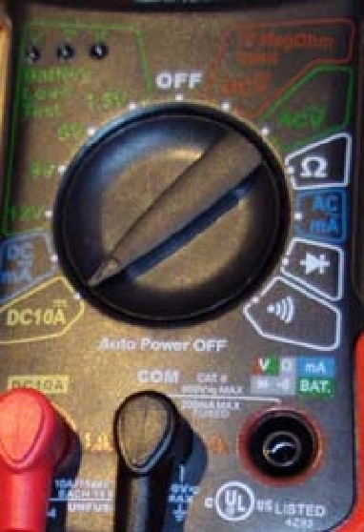
- Time to measure the current, start by changing the setting on the multimeter to the ones shown in the picture to the right

- Using the circuit diagram below measure the current through each of the lamps.

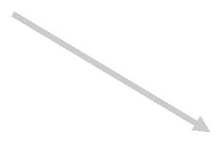
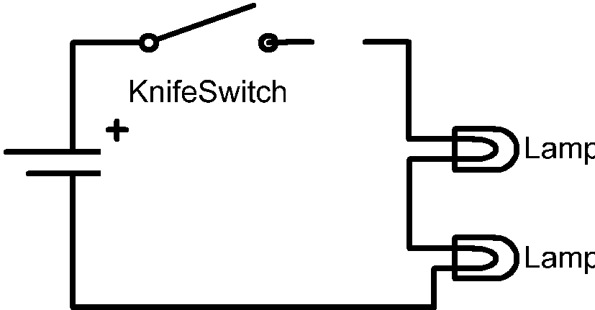
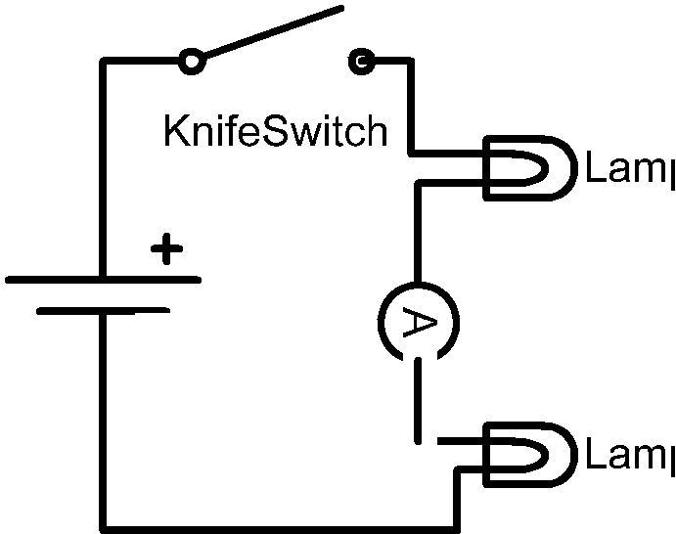

-

  - - Circuit to measure current in lamp 1

- If you have the circuit built from the last page disconnect the jumper wire that connected lamp 1 to the switch.

- Touch the red probe to the open end of the switch.

- Touch the black probe to the end of the lamp 1 that is not connected to anything.

- Record the current

Lamp 1 Current I_{L1} = __________ (A)

(where I is the standard symbol for current and (A) stands for Amperes which is C/s, or Coulombs per second.)

-

  - - Circuit to measure current in lamp 2

- From (1) reconnect lamp 1 to the switch and disconnect the jumper connecting the lamps together.

- Touch the red probe to the unconnected side of lamp 1.

- Touch the black probe to the end of the lamp 2 that does not connected to anything.

- Record the current

Lamp 2 Current I_{L2} = _________ (A)

(where I is the standard symbol for current and (A) stands for Amperes

Compare the currents:

Was your hypothesis correct?

Lamps in Series - Put it Together

- Ohm’s law states that the voltage is proportional to the resistance times the current or V=IR.
- Power dissipated by an electrical component found by multiplying the current times the voltage or P=VI

Look back at your previous work and record the voltage and current for each lamp in the spaces below.

 | X | = | = P_{L1}
VL1 | (V) | I_{L1} (A) | Lamp 1 Power (W)
 | X | = | = PL2

V_{L2} (V) I_{L2} (A) Lamp 2 Power (W)

What is the resistance

In the space below rearrange Ohm’s law to solve for the resistance.


Resistance | Law
Resistance | Ohm’s
the | Ohm’s
for | Ohm’s
for | Using
Solve | Using

Answer written

In the space below use your derivation above and calculate the resistance of each lamp in the appropriate section. Answer written


Answer written

Resistance | Law
Resistance | Ohm's
2 | Ohm's
2 | Using
Lamp | Using

Lamps in Series

Using all the information calculated up to now we are going to compare the measured and ideal case for the series circuit.

Start by summarizing the collected data:

Voltage supplied by the Batteries: _________(V)

Not under a load

Voltage across Lamp 1 V_{L1}:______________(V)

Voltage across Lamp 2 V_{L2}:______________(V)
Current through Lamp 1 I_{L1}:______________(A)

Current through Lamp 2 I_{L2}:______________(A)

Calculated resistance Lamp 1 R_{L1}:_________(Ω)

-
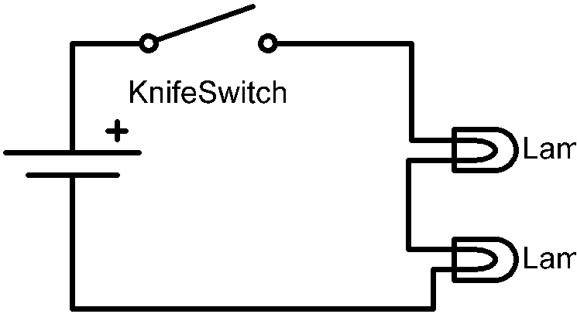

Circuit with 2 lamps in series

Calculated resistance Lamp 2 R_{L2}: (Ω)

To start this, the resistance of each lamp needs to be measured. To do this put the red probe in the port on the right, which has a Ω over it. The turn the multimeter measurement selector to Ω. Place the probes such that the red probe is on one side of the lamp to be measured and the black probe is on the other side.

Measured resistance Lamp 1 R_{L1}:______________(Ω)

Measured resistance Lamp 2 R_{L2}:______________(Ω)

From page 2 we know that resistors in series add, so find the equivalent resistance and then calculate the current. We will use the computed and measured current to compare the Ohm’s law to the measured current.

Equivalent Resistance = R_{L1} + R_{L2} → R_{equiv}:____________________(Ω)

Calculated Current I, using Ohm’s law V=IR_{equiv,} I = ____________________(A)

Average Measured current I_{L1,L2 AVG} = ____________________(A)

Calculate the % difference between I and I_{L1,L2 AVG} :____________________(%)

- How do the two current compare?:

- Χαν Οημ’σ Λαω βε υσεδ το πρεδιχτ χιρχυιτ ρεσπονσε?:

 | Lamps in Parallel
• From the previous page you know that
resistance is temperature dependent. The
parallel circuit should be similar to the one
you built on page 3 and is brighter than the
lamps in series. The brighter the bulb the |  |  |  |  | -
higher the resistance and I have found that
scaling by 1.4 is a good approximation.
Estimate the current and power through
each lamp using the calculated resistance
scaled by 1.4. |  |  |  |  |  |  |  |  |  |  |  |  |  | i1 |  |  |  | i2
• You need to calculate the current through each
resistor. To do this you need to know the voltage
across each resistor, we already know the resistance |  |  |  |  |  |  |  |  | -
from the previous page and check the bullet above.
• Using the space below calculate the currents.
Scaled R1 = | (Ω) | Scaled R2 = |  |  |  |  |  |  |  |  |  |  |  |  |  |  |  | (Ω)



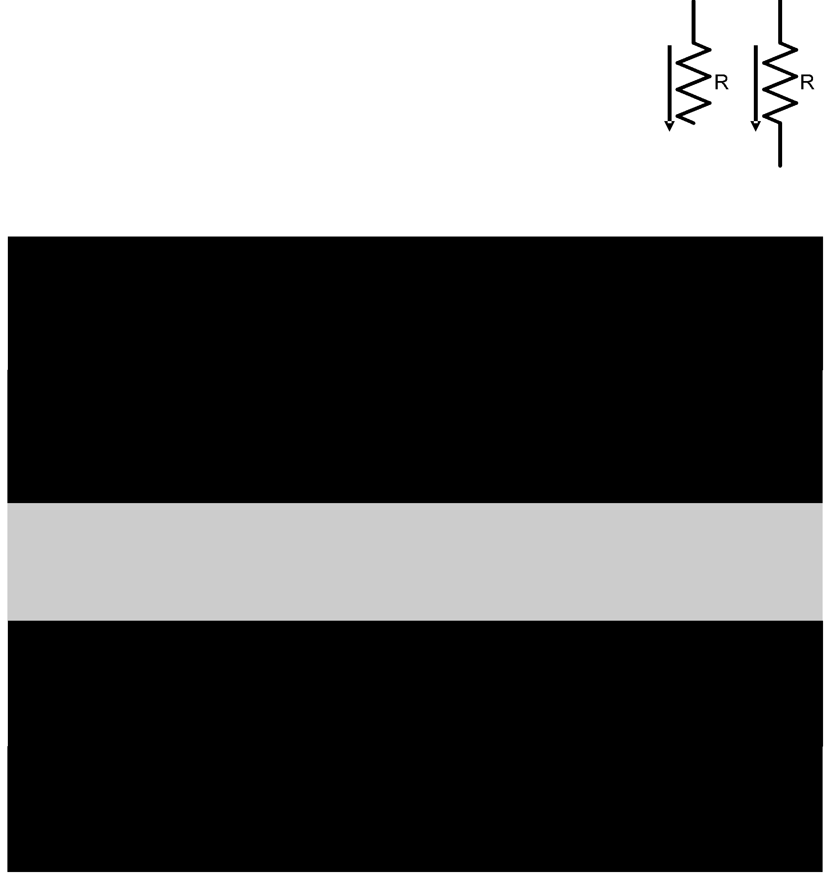

1 | Ohm’s
i | Ohm’s
Current | Ohm’s | Law
Current | Using
2 | Ohm’s
i
Current |  |  | Law
Current | Using |  | Law

Answer written

Answer written

• What voltage did you use and why?

the |  |  | 1
the | P
Calculate
Calculate | Power
the |  | 1
 |  | P
Calculate
 |  | Power

Answer written neatly

Answer written neatly

Lamps in Parallel - Build and Measure

- Build the circuit below and then measure the current and voltage for each lamp.
- Label the circuit below with the measure values adding the polarity and direction of the current.
- Fill in the measured values below the circuit


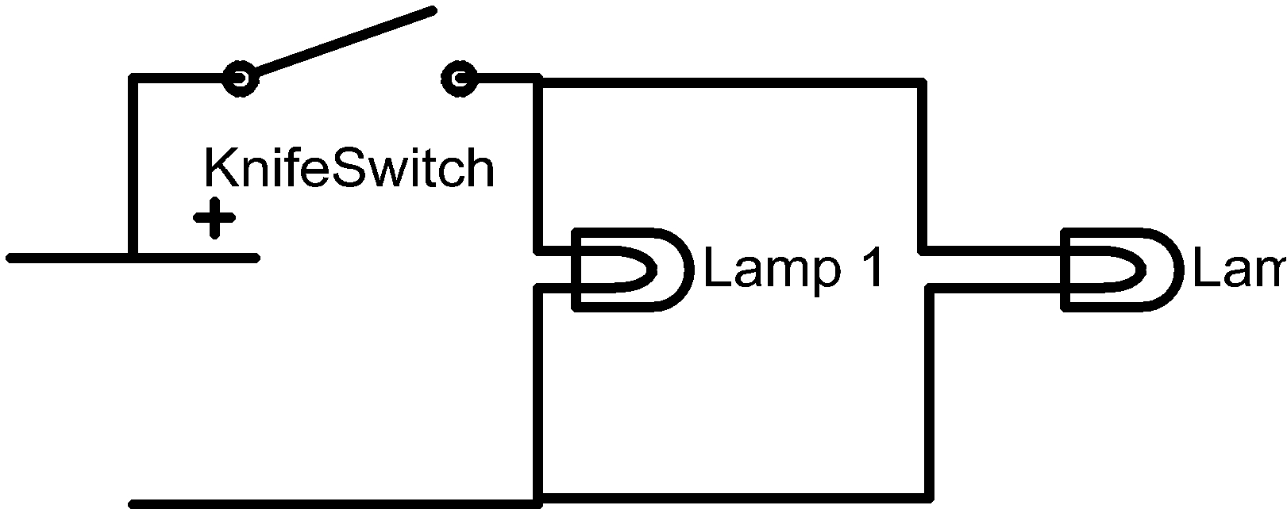

-

Measured | Calculated (Previous | % Difference
 | Page) | (See Page 2)

Voltage Lamp 1
(V_{L1})

Current Lamp 1
(I_{L1})

Power Lamp 1
(P_{L1})

Voltage Lamp 2
(V_{L2})

Current Lamp 2
(I_{L2})

Power Lamp 2
(P_{L2})

- How well did you estimate the power and current through each lamp?

- What are things that you could do to improve the prediction or calculated values?

- What are things that you could do to improve the measured values?
What Was Observed?

- Which were brighter the lamps in parallel or the lamps in series?

- Explain the circuit you came up with when trying to make the lamps shine the brightest?

- Can you now quantify the brightness by associating it with the power dissipation?

- How accurate is it to associate the brightness with the power dissipation?

Fill in the table below using the power measured in the series and parallel circuits

Power Lamp 1 | Power Lamp 2 | Total Power
 |  | Lamp 1 + Lamp 2

Series Circuit

Parallel Circuit

Factor
(Parallel/Series)

• By what factor on average were the lamps in parallel brighter than the series (< 1 Series circuit brighter, > 1 parallel circuit brighter) and why?

Challenge Question:

• Is there a way to calculate this factor algebraically (In the space below prove )?

(The equations on page 2 will help prove your answer)
How to analyze circuits with more than two components

Start by replacing the parallel resistors with a single resistor, Circuit 12-b shows the resulting circuit.


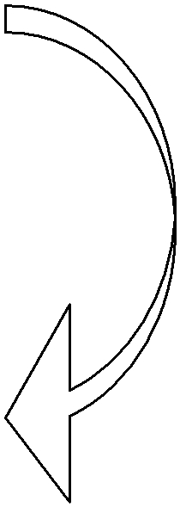


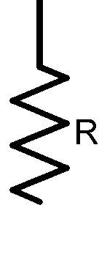


 |  |  | -
 | Circuit 12-a
R_{eq_parallel} = _____________________ (Ω)
Now that you have R_{eq_parallel} use the fact that
R1 is in series with R_{eq_parallel} to find R_{equiv}.
R1 is in series with R_{eq_parallel} to find R_{equiv}. |  | -
 | Circuit 12-b


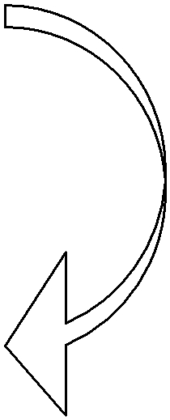
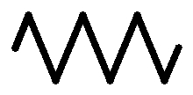


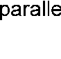
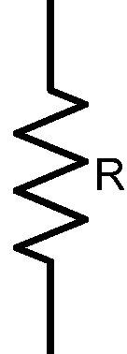

 |  | -
R_{equiv} = _____________________(Ω) | Circuit 12-c

Let R1 = 9.15 (Ω), and R2 = R3 = 3.6 (Ω), calculate the current through R_{equiv} assuming that V1=2.9 (V).

Current through I_{equiv} := ______________(A)

Using KCL find the current through R2 and R3. I_{R2} = ________________(A)
I_{R3} =________________(A)
How to analyze circuits with more than two components

Build this circuit and measure the current through each lamp. Enter the measured values in the spaces below.
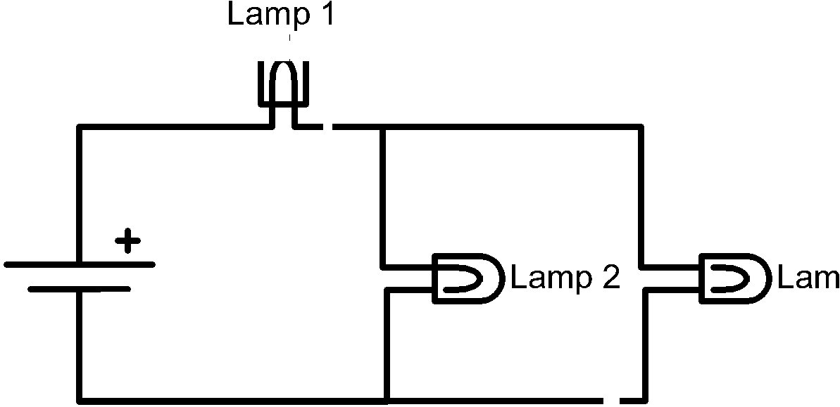
(Groups may need to join
in order to have enough | -
lamps.) | -

Voltage across V_{lamp 1} = _____________________ (V)

Voltage across V_{lamp 2} = _____________________ (V)

Voltage across V_{lamp 3} = _____________________ (V)

Current Through Lamp 1 I_{lamp 1} = _____________________ (A)

Current Through Lamp 2 I_{lamp 2} = _____________________ (A)

Current Through Lamp 3 I_{lamp 3} = _____________________ (A)

How close is 1 I_{lamp 1} to I_{equiv} ? If the percent difference is more than 5% calculate the resistance for each lamp and compare the resistance for each lamp.

Current through I_{equiv} := ______________(A)

%Difference = ______________________(%)

Does the current through lamp 1 equal the sum of the current through lamp 2 and lamp 3?
How to use the KVL

Using Kirchhoff’s voltage law circuit like the one to the right can be solve. Three loops must be taken (left, right, and bottom) these loops will yield 3 equations which are related. For consistence choose loops that are clockwise, the dot represents the starting position for each loop.

Note that the loops are thought of as current loops since voltage is the product of current and resistance. So the current through R2 is the difference of the currents I1 and I2, see the equations below for
l ifi i
Note that loop 3 or L3: is a loop around the outer edge or the circuit.

Each equation need to be rearranged collecting the I’s together since they are the unknowns

Use the given resistances to the right for each lamp to eliminate all the R’s and use the measured voltage for the batteries in series to replace V1. Then solve by hand or using a calculator to find the currents I1, I2, I3, I4. Once done build the circuit, measure the current through each lamp and compare with the calculated values.

- | I1 | I2
 |  | I3
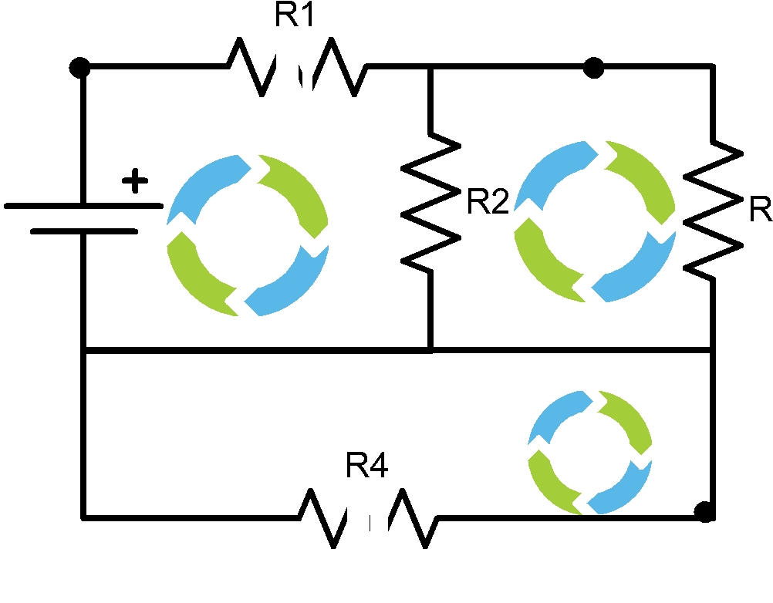

L1: R1⋅I1+R2(I1−I2) −V1=0 L2: R3⋅I2+R2(I2−I1) =0

L3: R4⋅I3−V1+R1⋅I1+R3⋅I2 =0

Rearranged ↓

L1: (R1+R2)I1−R2⋅I 2 =V1 L2 : −R2⋅I1+(R3 +R2)I 2 =0 L3: R1⋅I1+R3⋅I 2 +R4⋅I3 =V1

R1 = 9.14 (Ω) |  | R3 = 3.61 | (Ω)
R2 = 3.61 (Ω) |  | R4 = 7.2 | (Ω)

Fill in the table below using the power measured in the series and parallel circuits

Calculated | Measured | % Difference

I1

I2

I3

Use KVL to solve for the currents in this circuit

Similar to the previous page label the loops, get the system of equations and solve for the current.

The space below had be provided to write out the equations. Once the currents have been calculated build the circuit and measure the current entering all the information into the table below.

R1 = 7.06 (Ω) | R3 = 6.86 (Ω)
R2 = 7.33 (Ω) | R4 = 6.82 (Ω)

-
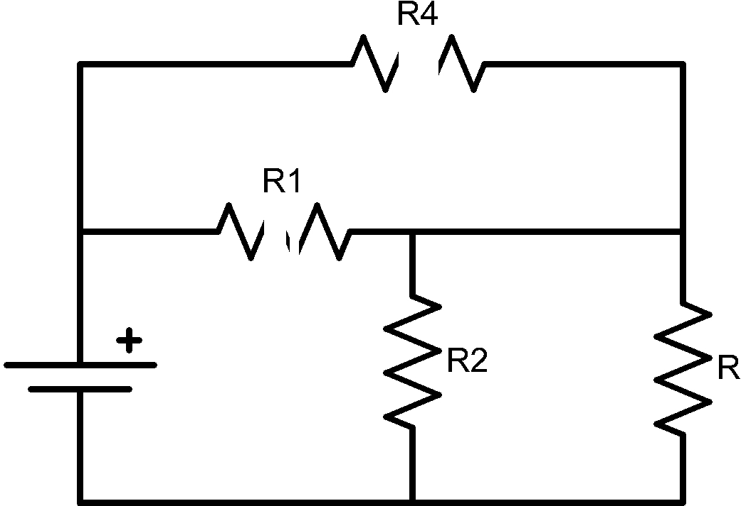

Fill in the table below using the power measured in the series and parallel circuits

Calculated | Measured | % Difference

I1

I2

I3

