Example Data:
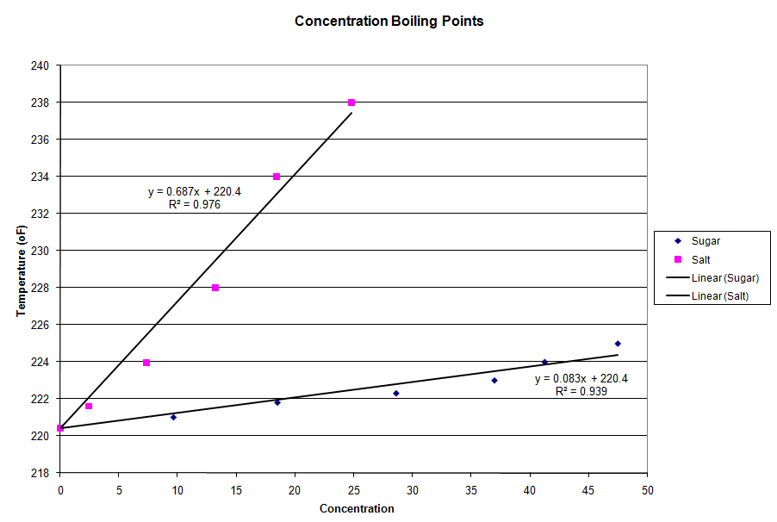
Salt Data:
Msoulte  (gram) | MH20  (gram) | Msolution  (gram) | Concentration  (%) | Tboil  (ºF)
0 | 200.0 | 200.0 | 0.00 | 220.4
5 | 199.1 | 204.1 | 2.45 | 221.6
15 | 189.7 | 204.7 | 7.33 | 223.9
30 | 196.8 | 226.8 | 13.23 | 228.0
45 | 199.7 | 244.7 | 18.39 | 234.0
65 | 197.1 | 262.1 | 24.80 | 238.0
80 | 195.5 | 275.5 | 29.04 | 238.0

Sugar Data:
Msoulte  (gram) | MH20  (gram) | Msolution (gram) | Concentration % | Tboil (ºF)
0 | 200.0 | 200.0 | 0.00 | 220.4
20 | 187.6 | 207.6 | 9.63 | 221.0
45 | 198.6 | 243.6 | 18.48 | 221.8
80 | 200.0 | 280.0 | 28.57 | 222.3
115 | 196.4 | 311.4 | 36.93 | 223.0
140 | 199.8 | 339.8 | 41.20 | 224.0
180 | 199.6 | 379.6 | 47.42 | 225.0

General Calculations based on above data:
1. Salt Solutions:
It requires 2.8grams salt for every 200mL water to increase the boiling point by 1ºF. Therefore, would take 11.06grams to increase the boiling point of 200mL water by 4ºF.

2. Sugar Solutions:
It requires 38.3grams sugar for every 200mL water in increase the boiling point by 1ºF. Therefore, it would take 153.2 grams to increase the boiling point of 200mL water by 4ºF.

