Section 1 worksheet

Name: ______________________________________________ Class: __________________

Date: __________________
Concentrate This! Sugar or Salt Introduction
- Solutions:

EXAMPLE:
Coffee crystal = solute
Water = solvent
Liquid Coffee = solution

So a solute is dissolved in solvent to make a solution

- Solution Concentration = how much solute dissolved in solvent
Express concentration by a mass (%) = $\frac{\text{Mass Solute}}{\text{Mass Solution}}×\text{100}$

- Boiling Point Changes with Concentration

The boiling point of a solvent is elevated by adding a non-volatile solute.
This can be shown by performing experiments and plotting with a graph.

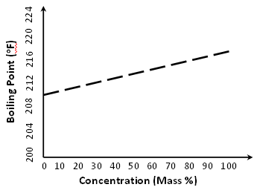

- Reading Thermometer

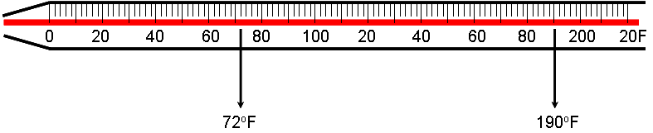

Creating a Solution:
Step 1. Choose either SALT or SUGAR as your solute for Activity 1 (circle one)
Step 2. Weigh solute and Record in Table 1= Mass Solute
Step 3: Weight Empty beaker and Record in Table 1
Step 4: Add 200ml water to empty beaker , Weigh and Record in Table 1
Step 5: Calculate… Step 4 - Step 3 = Mass Solvent Record in Table 1
Step 6: Calculate… Step 2 + Step 5 = Mass Solute + Mass Solvent = Mass Solution Record in Table 1
Step 7: Calculate… $\frac{\text{Mass Solute}}{\text{Mass Solution}}×\text{100}$= Concentration Record in Table 1
Boiling Point Testing:
Step 8: Make a foil lid for beaker (use a rubber band to secure over beaker)
Step 9: Make a small hole in lid for the thermometer to be inserted.
Step 10: Place beaker solution on burner and wait for it to boil. Boiling is described by a rapid and continuous boiling.
Step 11: Record the boiling temperature in Table 1; make sure thermometer is not touching sides of beaker.
Step 12: Drain, rinse, and dry beaker.
Step 13: Repeat from Step 1 (but now weigh a different amount of the same solute).
Step 14: Repeat from Step 1 again...should have three rows complete in Table 1 once you finish testing.
Table 1: Section 1 Testing
Mass Solute (grams) | Mass Empty Beaker (grams) | Mass Beaker + H₂0 (grams) | Mass Solvent (grams) | Mass Solution (grams) | Concentration (%) | Boiling Point (ºF)
STEP 2 | STEP 3 | STEP 4 | STEP 5 | STEP 6 | STEP 7 | STEP 11
0 | - | - | - | - | 0 | 220

12. Create a scatter plot of your test data & draw a single line to connect the points.
- x-axis = Concentration
- y-axis = Boiling Point

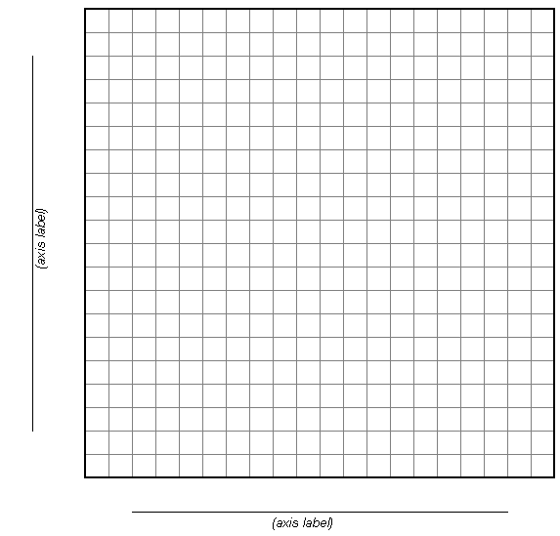

Goal: Lowest cost solution that will have a boiling point T_{boil} = 117ºF

Engineering Design: Determine which solute will yield the cheapest solution. You will still use 200mL water as your solvent

Testing:
1. You have data for one solute already plotted on the graph on Page 3. Now plot the data for the 2nd solute (use the same graph).
2. Draw a single line connecting the 2nd set of points & label each line (so you know which line is which).
3. Draw a horizontal line across your graph at a boiling temperature = 117ºF. (should cross both solute lines)
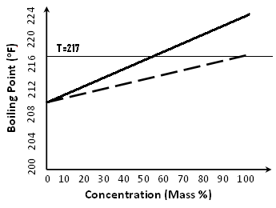
4. Draw a vertical line down from where your horizontal line crosses each solute line
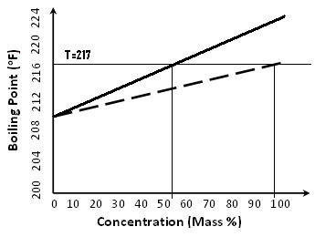
These are the two concentrations you have to choose from.
5. Record the two concentrations from your graph that will yield a solution with a boiling point of 217ºF
SALT Concentration = _____________ %
SUGAR Concentration = _____________ %
6. Determine mass required for making each solution. Use the following equation to calculate the solute mass required.
$$\text{Mass Solute }=\frac{\frac{\text{Concentration \%}}{\text{100}}×\text{Mass Solvent}}{\left(1−\frac{\text{Concentration \%}}{\text{100}}\right)}$$
Mass Salt =

Mass Sugar =

7. Determine cost of each solution: Salt = $0.0006/gram salt & Sugar = $0.002/gram sugar
Cost Salt Solution =

Cost of Sugar Solution =
8. Now test the best solution (test the same as yesterday) & record data in Table 2
Table 2: Section 2 Testing
Mass Solute (grams) | Mass Solution (grams) | Concentration ($\frac{\text{Mass Solute}}{\text{Mass Solution}}×\text{100}$%) | Boiling Point (ºF)

9. Calculate your error in the boiling point
% Error = $\frac{{\text{Actual Boiling Temperature-217}}^{o}F}{{\text{217}}^{o}F}×\text{100}\text{\%}$
% Error =

10. Record your Concentration and measured Boiling Point on the board.

