Section 2 Worksheet: Data Analysis

Name: ______________________________________________ Period: __________________

Date: __________________
Last visit each group tested the boiling point of either a salt or sugar solution. Data from each class was collected, averaged, and appears in the table below.

1. Before you can go back to the lab tables you need to first plot the two sets of data.
- x-axis = Concentration
- y-axis = Boiling Point

SALT Solutions SUGAR Solutions
Msoulte | Msolution | Concentration | Tboil
0.0 | 200.0 | 0.0 | 220.4
5.0 | 204.1 | 2.5 | 221.6
15.0 | 204.7 | 7.3 | 223.9
30.0 | 226.8 | 13.2 | 228.0
45.0 | 244.7 | 18.4 | 234.0
65.0 | 262.1 | 24.8 | 238.0
80.0 | 275.5 | 29.0 | 238.0
Msoulte | Msolution | Concentration | Tboil
0.0 | 200.0 | 0.0 | 220.4
20.0 | 207.6 | 9.6 | 221.0
45.0 | 243.6 | 18.5 | 221.8
80.0 | 280.0 | 28.6 | 222.3
115.0 | 311.4 | 36.9 | 223.0
140.0 | 339.8 | 41.2 | 224.0
180.0 | 379.6 | 47.4 | 225.0

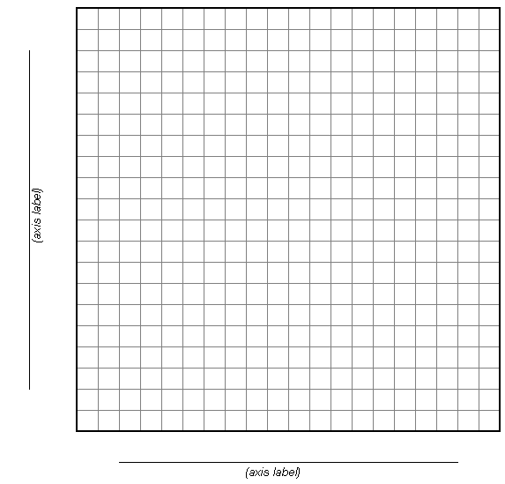
2. Draw a single line (best fit line) to represent the salt solutions
3. Draw a single line (best fit line) to represent the sugar solutions.
4. Draw a horizontal line across your graph at a boiling temperature = 224ºF. (should cross both solute lines)
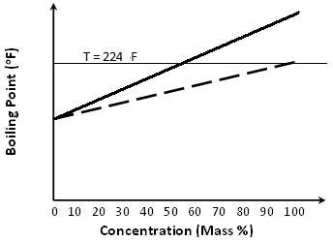
5. Draw a vertical line down from where your horizontal line crosses each solute line
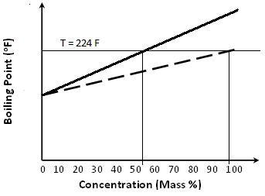
These are the two concentrations you have to choose from to achieve the desired boiling temperature.
6. Record the two concentrations from your graph that will yield a solution with a boiling point of 224ºF
SALT Concentration = _____________ %
SUGAR Concentration = _____________ %
7. Determine mass required for making each solution. Use the following equation to calculate the solute mass required.
$$\text{Mass Solute }=\frac{\frac{\text{Concentration \%}}{\text{100}}×2\text{00}}{\left(1−\frac{\text{Concentration \%}}{\text{100}}\right)}$$
Mass Salt = g

Mass Sugar = g
8. Determine cost of each solution: Salt = $0.0006/gram salt & Sugar = $0.002/gram sugar
Cost Salt Solution =

Cost of Sugar Solution =

