Magnetic Launcher Worksheet Name________________________________

Date_________________________________

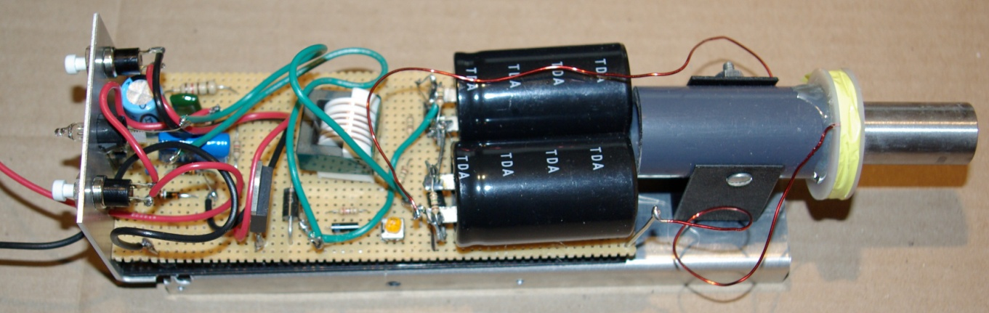
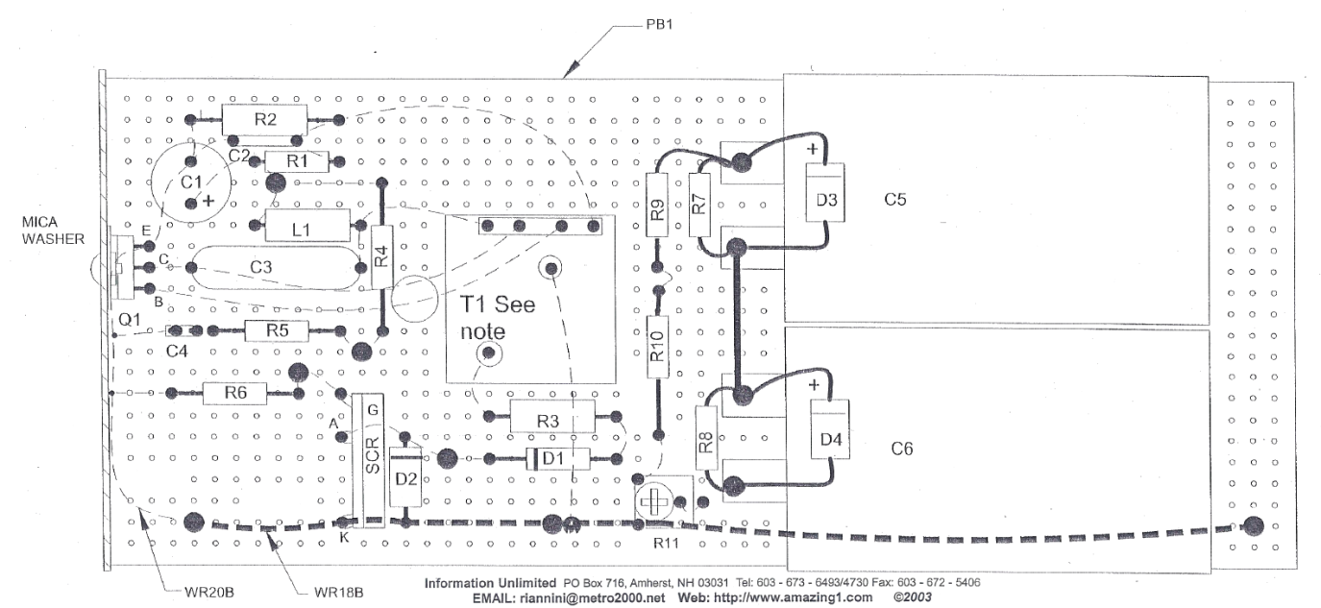
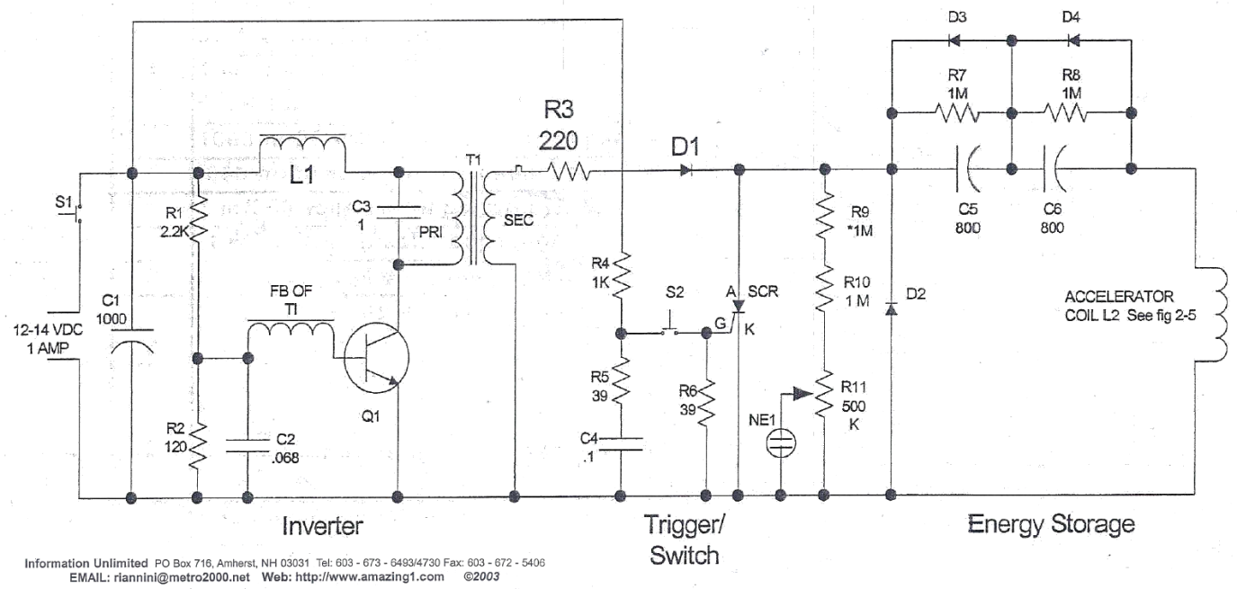
Teacher:__________________________ Period:______

Initial Calculations

• Lesson goal - Explore magnetic induction
• Lesson goal - Determine the time required to launch the projectile
• Lesson goal - Use experimentation to determine best design model
- Lesson goal- Describe how engineers employ calculations to make predictions using various design constraints and experimental measurements

In order to estimate a launch time the easiest approach is to find the initial velocity and then calculate the kinetic energy after being accelerated. This information can be used to calculate the time by relating it to the power.

1. First step is to derive and equation for the initial velocity

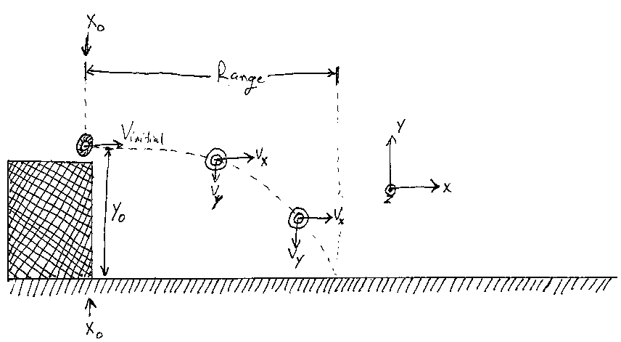
Equations of motion
• Using the equations of motion below get an equation to find the initial velocity of the projectile.
• Remember that a_{x} = 0 while a_{y} = g (g=-9.81m/s)
•$a_{y}=\frac{{\text{dv}}_{y}}{\text{dt}}=g$ Use the sketch below to identify the meaning of the variables.
x_{o} = initial x location
y_{o} = initial y location
a_{x =} acceleration in the x direction
a_{y =} acceleration in the y direction
v_{x =} velocity in the x direction = v_{o}cosθ
v_{y =} velocity in the y direction = v_{o}sinθ
t = time in seconds
v_{o} = initial velocity
θ = launch angle above horizontal, θ = 0

$a_{x}=\frac{{\text{dv}}_{x}}{\text{dt}}=0$

$v_{x}=v_{\text{xo}}+a_{x}t$$v_{y}=v_{\text{yo}}+a_{y}t$

$x=x_{o}+v_{x}t+\frac{1}{2}a_{x}t^{2}$$y=y_{o}+v_{y}t+\frac{1}{2}a_{y}t^{2}$

• Use the equations above to find the velocity of the projectile as it leaves the launcher
The following questions will help in solving for the initial velocity
• What is x_{o}?
• What is v_{x} equal to at the launcher?
• What is v_{y} equal to at the launcher?

Equation for the initial velocity

Experiment
Safety Glasses Required

Now it is time to collect data.
• There are a total of 9 launchers
• 3 Launchers with the number 1 were constructed using 30.5 turns on the bobbin
• 3 Launchers with the number 2 were constructed using 40.5 turns on the bobbin
• 3 Launchers with the number 3 were constructed using 50.5 turns on the bobbin

Each group needs to collect data from a launcher with 30.5, 40.5, 50.5 turns and must take 3 samples in order to calculate the standard deviation. Follow the instructions below to fire and collect data from each launcher. Team work and attention to detail will improve the accuracy of the data collected.
1. Make sure that there is no one in front of the launcher
2. Place the aluminum projectile on the steel rod and slide it up as close to the white bobbin as possible.
3. Press the charge button on the right
4. When the light glows press the fire button on the left.
5. Measure the distance from the launcher to where the projectile first landed
6. Record the distance and repeat the process until you have 3 trials then collect data from the next launcher.

 | Launcher 1  30.5 Turns | Launcher 2  40.5 Turns | Launcher 3  50.5 Turns
Trial 1 (units?) (___)
Trial 2 (units?)(___)
Trial 3 (units?)(___)
Average
Standard Deviation
• Which launcher had the longest average range?
• Which launcher had the largest standard deviation?
• What things could you do to improve the accuracy of the data collection?
• How is the projectile being launched?
Analyze
Equation  for initial  velocity | Average Range  Launcher 1 | Standard  Deviation  Launcher 1 | Average Range  Launcher 2 | Standard  Deviation  Launcher 2 | Average Range  Launcher 3 | Standard  Deviation  Launcher 3
Summarize Work Done:

Calculate the average initial velocity and the min/max initial velocity for each launcher:
 | Average Initial Velocity | Minimum Initial Velocity  (V_{avg} - Standard Deviation) | Maximum Initial Velocity  (V_{avg}+ Standard Deviation)
Launcher 1
Launcher 2
Launcher 3
$K=\frac{1}{2}{\text{mv}}^{2}$A standard way of comparing projectiles is to look at the energy of the projectile so lets calculate the energy of the projectile at the launcher. To due this we will that all the projectiles energy is kinetic energy. The formula for kinetic energy is:
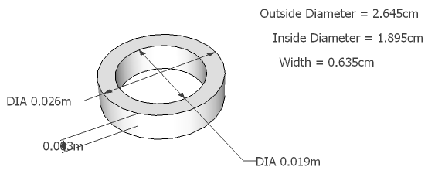
Where K is the kinetic energy, m is the mass of the projectile and v is the initial velocity. Recall unit of energy are joules or Newton meters (N∙m). Power is joules per second or watts (W).
Figure drawn with Google Sketchup, Sketch dimensions in meters. Use the more exact dimensions listed in upper right this will be easier since density is in cubic cm or cm³.

Use the dimensions in the figure to the right and the knowledge that the density of aluminum is 2.7 g/cm³ to calculate the mass of the projectile (check width with a ruler if different, use measured width over given width).
Figure drawn with Google Sketchup, Sketch dimensions in meters. Use the more exact dimensions listed in upper right this will be easier since density is in cubic cm or cm³.

Mass of Projectile:__________________________

 | Average Energy | Minimum Energy  (Use minimum velocity) | Maximum Energy  (Use maximum velocity)
Launcher 1
Launcher 2
Launcher 3
Analyze Results
• Which launcher worked the best? ______________________________________________
• How long do you think it took a projectile to be accelerated off the steel rod? _________(s)
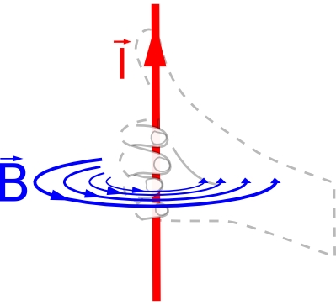
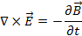
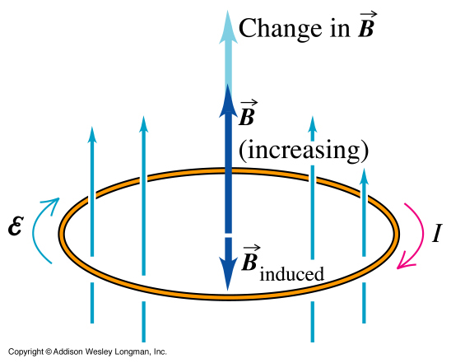
Faraday’s law states the current or a moving charge induces a magnetic field following the right-hand-rule convention shown in the figure. Faraday's Law can be written mathematically as:
Lenz’s law states that the current induced by a magnetic field is in a direction such that the induced current will induce a magnetic field in the opposite direction of the original or instigating magnetic field.

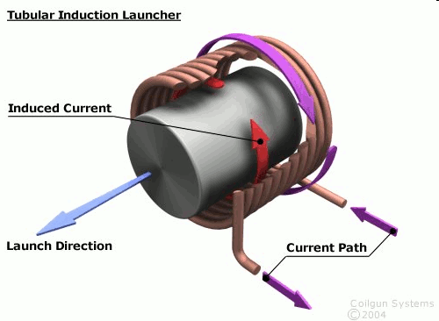

These two laws are the theories behind the magnetic launcher.
• Using the figure to the right and the right-hand-rule determine the direction of the induced magnetic field from the outside windings (purple arrow). Assume that the arrow head side of the magnetic field is north.
• Draw an arrow in the opposite direction as the instigating the induced magnetic field. Again using the right-hand-rule is the magnetic field you just drew consistent with the induced current (red arrow)? __________________________________________

Now lets estimate the time that the projectile was on the steel rod, in an ideal case? To do this you will need the energy calculated on the previous page, Ohm’s law and the power equation. Use the following equations and information to solve for the time.
• Ohm’s Law - V=IR
• Power equation - P = IV (Watts)
• Watts = Joules/second
• Resistance = 0.5Ω
• Voltage = 600V

Estimated Time ______________(s)

