Gas Bags: Instructor Directions

Materials needed:
- 60 mL plastic syringe
- 1 L (qt) freezer-quality food storage bag
- tubing, 1/8 inch (3.175 mm) ID, 15 cm length
- plastic hemostat or pinch clamp
- dish soap
- Chemicals:
  - Hydrogen
    - 1g Magnesium (powdered)
    - 50mL 1.2M HCL(aq)
  - Oxygen
    - 0.5 g potassium iodide
    - 60 mL 3% H₂O₂ (aq)
Construction:
- Use a pencil or similar round, sharp object to poke a hole through the plastic bag in a position similar to that shown in Figure 1.
- Moisten one end of the piece of tubing with dish soap in order to facilitate pushing it through the hole in the bag.
- The gas bag is now ready for testing. Fill a large pail (10 L) with water. Inflate the gas bag with air. Hold the point of connection between the gas bag and the tubing under the water and check for leaks (or place some water in the bag and let it pool near the tubing and then check for leaks on the outside of the bag). We have found that there are seldom leaks. The seal, however, often leaks slowly, but in most cases slow leaks are of little consequence.
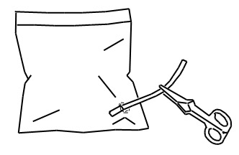
Figure 1: 1 L Gas Bag
Gas Production:
- Hydrogen is prepared using 1 g powdered magnesium (inside the bag) and 50 mL of 1.2M HCl(aq) admitted via the tubing. The reaction becomes quite warm and is complete within one minute. Other forms of magnesium (turnings, ribbon) also can be used.

- Oxygen is prepared using 0.5 g potassium iodide (inside the bag) and 60 mL 3% H₂O₂ (aq) admitted via the tubing. The reaction is considerably slower; it takes about 5 minutes.

