Student 1 Name: ___________________________________ Date: ____________________

Student 2 Name: ____________________________________ Class: ____________________

Part 2: Myth Busters’ Investigation
In Part 2 we will be testing the following three hypotheses using different liquids on a plastic coin and a copper penny (which you weighed and measured yesterday). As we test each liquid you will be recording your data in Table 6 (on Page 2). You will want to keep track of your pennies and coins you have used so that you don’t test two liquids on the same one.

Question 1: Can a liquid film (film height>2mm) be stacked on a flat surface ?

Hypothesis:

Question 2: Can changing the liquid change the height of the liquid film (film height)?

Hypothesis:

Question 3: Can changing the surface material (penny versus coin) change the height of the liquid film (film height)?

Hypothesis:

Drop Formation Considerations:
- the speed you dispense a droplet from pipette will affect the drop size
- the height above the surface that you release the droplet will affect the number of drops
- the location on the surface that each droplet lands will affect the number of drops

Write your detailed procedure for forming droplets: this should be the same procedure you used yesterday.
1. Speed:

2. Height:

3. Location:

Values from Part 1:

Liquid | $${\bar{m}}_{\text{drop}}$$  (g) | $${\bar{V}}_{\text{drop}}$$  (mL) | $${\bar{d}}_{\text{drop}}$$  (mm) | $$ρ$$  (g/mL)

 | Copper Penny | Plastic Coin
Mass (g)
Diameter (mm)

Materials & Procedures
You and your partner need:
- 3 clean copper pennies
- 3 clean plastic coins
- 3 pipettes
- 3 beakers (each filled with a different liquid)
Test Head-Side of Penny
- 1 ruler
- Student Testing Page

- In the first column in Table 6, write the name of each liquid being tested.
- Label the name of each liquid being tested on the Student Testing Page
- Perform a Drop Test for each liquid on both a penny and a coin.
- Drop Test Procedure:
  - Fill pipette with liquid and place one drop at a time on surface.
  - Count the number of drops that can fit on the surface before the liquid overflows.
  - Record the number of drops in Table 6 Trial 1.
  - Dry the surface.
  - On Trial 5 measure the height of the liquid film in millimeters (mm)
  - Record the liquid height on Table 6
  - Repeat drop test for Trial 2, Trial 3, Trial 4, and Trial 5.
- Calculate the Average number of drops for each test.
  - Record Average on Table 6.
- Calculate the Mass of Liquid, $M_{\text{Liquid}}=\left(N_{\text{Average}}\right)⋅{\bar{m}}_{\text{drop}}$
  - Record on Table 6
- Calculate the Volume of Liquid, $V_{\text{Liquid}}=\frac{M_{\text{Liquid}}}{ρ}$
  - Record on Table 6
Data Collection

Table 6
Record Number of Drops (N)
 | Trial 1 | Trial 2 | Trial 3 | Trial 4 | Trial 5 | $$N_{\text{Average}}$$ | Film Height (mm) | $$M_{\text{Liquid}}$$  (g) | $V_{\text{Liquid}}$  (mL)
Penny w/

Penny w/

Penny w/

Coin w/
Coin w/
Coin w/

Analysis

1a. Write and describe another mathematical equation you could use to calculate the volume of liquid on a penny. Write an equation to express your calculation.

b. Would there be a difference in the values between your method and the one used in Table 6? Show mathematically (using equations and variables).

2a. Create a bar graph showing the number of drops for each test.

b. Create a bar graph showing the volumes (Table 6 values) for each.

c. Create a bar graph showing the film height for each.

Figure 1 Figure 2

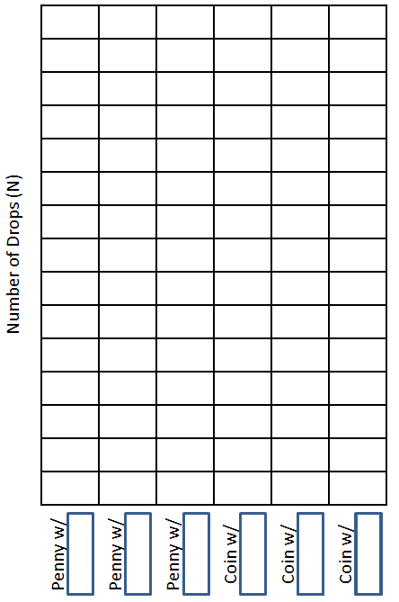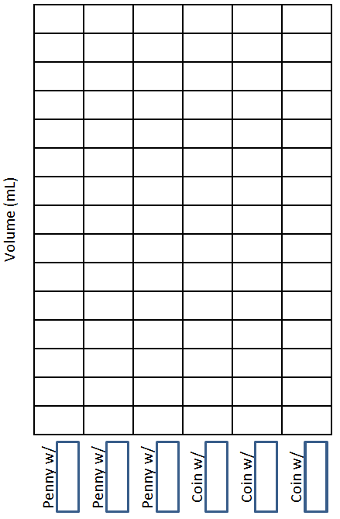

Figure 3

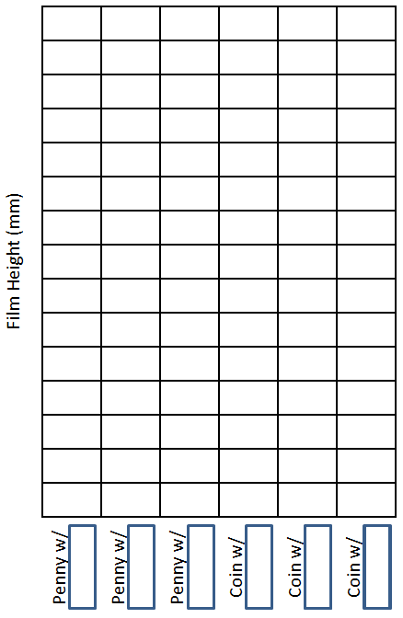

3a. What held the most number of drops?

b. What held the most drops?

c. What held the largest volume?

d. What held the smallest volume?

4a. Which surface material and liquid has the strongest adhesive force? How do you know?

b. Which surface material and liquid has the weakest adhesive force? How do you know?

5. Was your first hypothesis correct? If not then explain why it was incorrect.

6. Was your second hypothesis correct? If not then explain why it was incorrect.

7. Was your third hypothesis correct? If not then explain why it was incorrect.

